**NAME- AMAN KUMAR**

**COURSE- B.VOC SOFTWARE DEVELOPMENT**

**ROLL NO- 20232703**

**SUBJECT- FULLSTACK**

**13. Create, Insert and Delete a Document from a Collection**

**• Create a new database named studentDB.**

**CODE & OUTPUT:-**

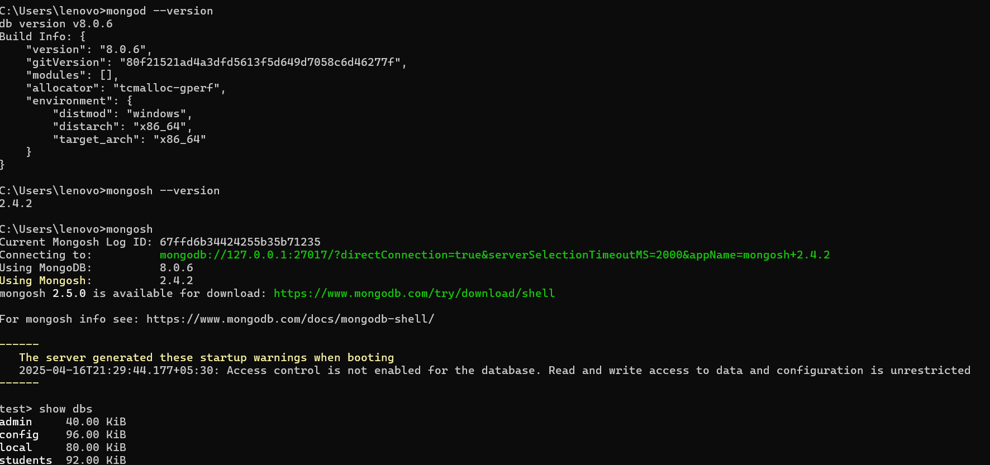

• Create a collection named students.

• Insert multiple documents with fields like name, age, and grade.

**CODE & OUTPUT:-**

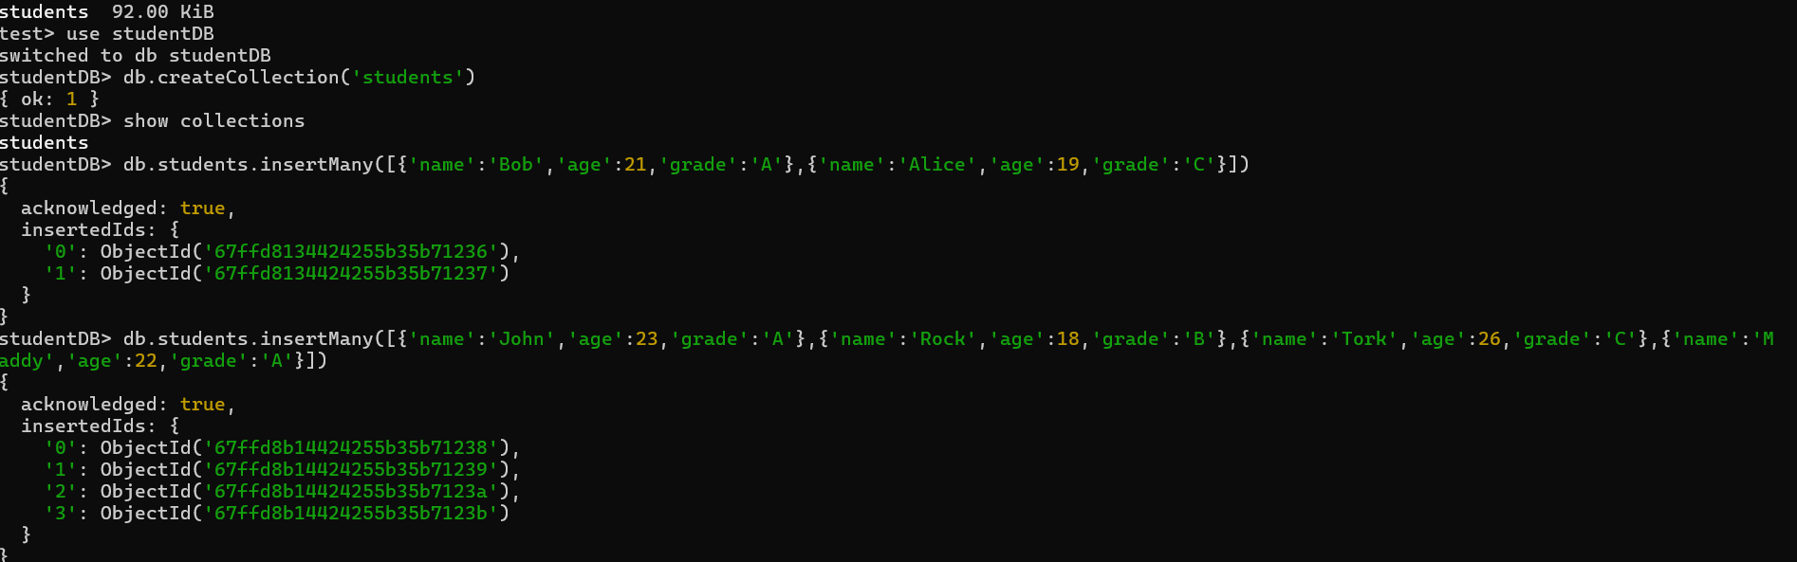

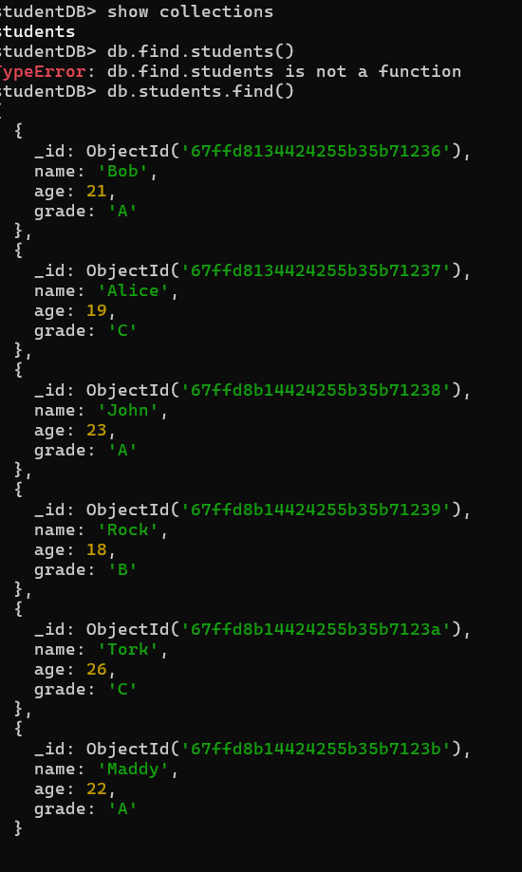

**• Delete the document where name is Bob.**

**• Use deleteOne() to remove the document.**

**CODE & OUTPUT:-** 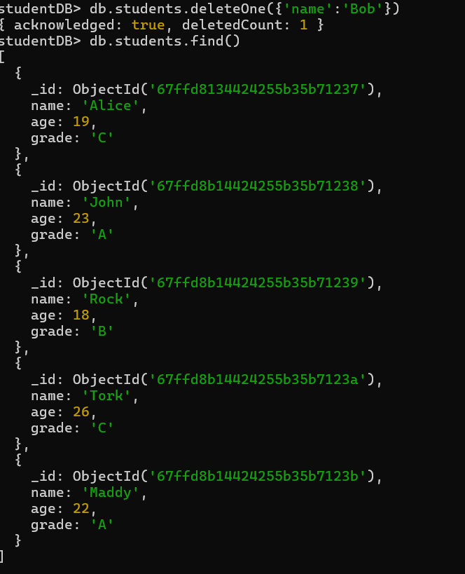

**14. Retrieve, Query and update Documents**

**• Retrieve all documents from the students collection.**

**• Query documents where grade is A.**

**CODE & OUTPUT:-**

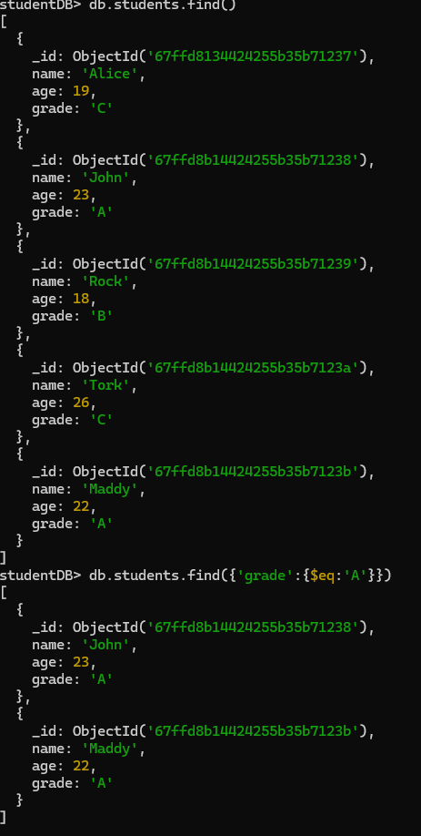

**• Update the age of a student named Alice to 21.**

**• Use updateOne() to modify the document.**

**CODE & OUTPUT:-**

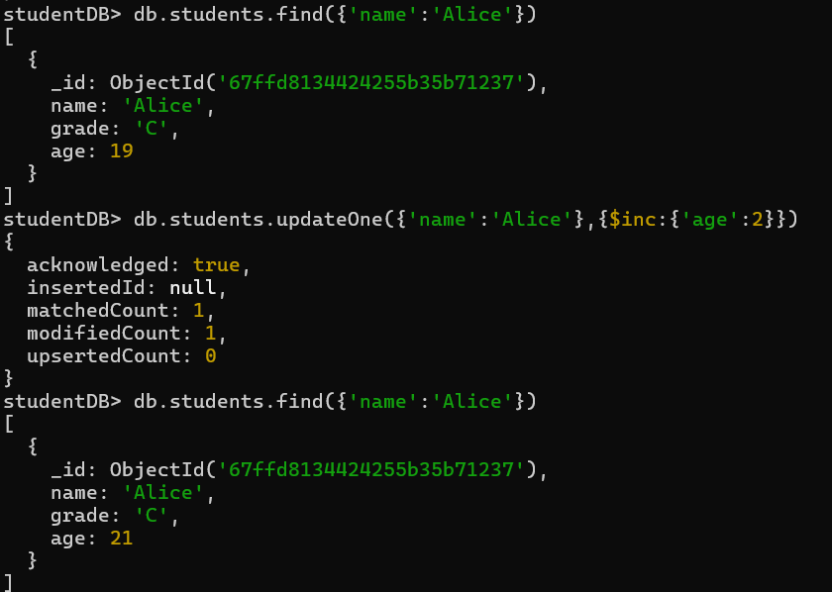

**15. Create and Apply Indexes for Faster Queries**

**• Create an index on the name field for faster search.**

**CODE & OUTPUT:-**

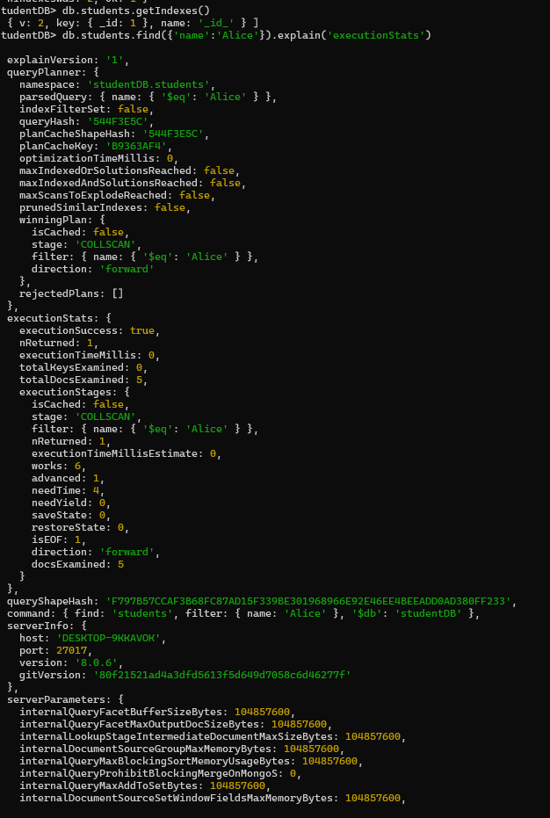

**• Verify the created index using getIndexes().**

**CODE & OUTPUT:-**

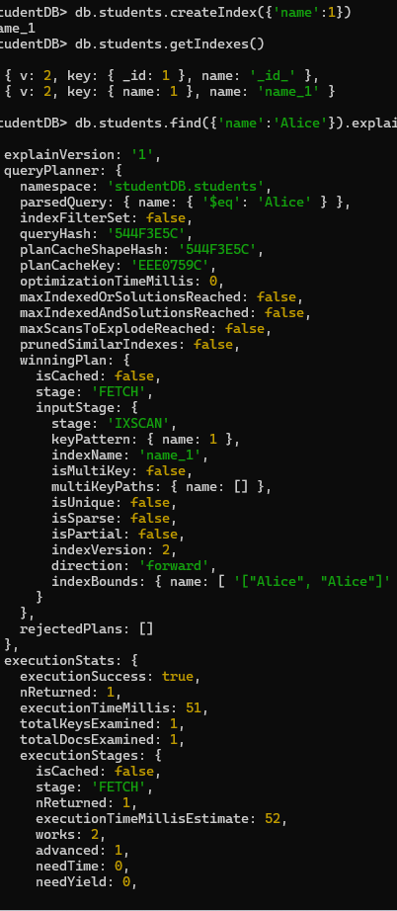

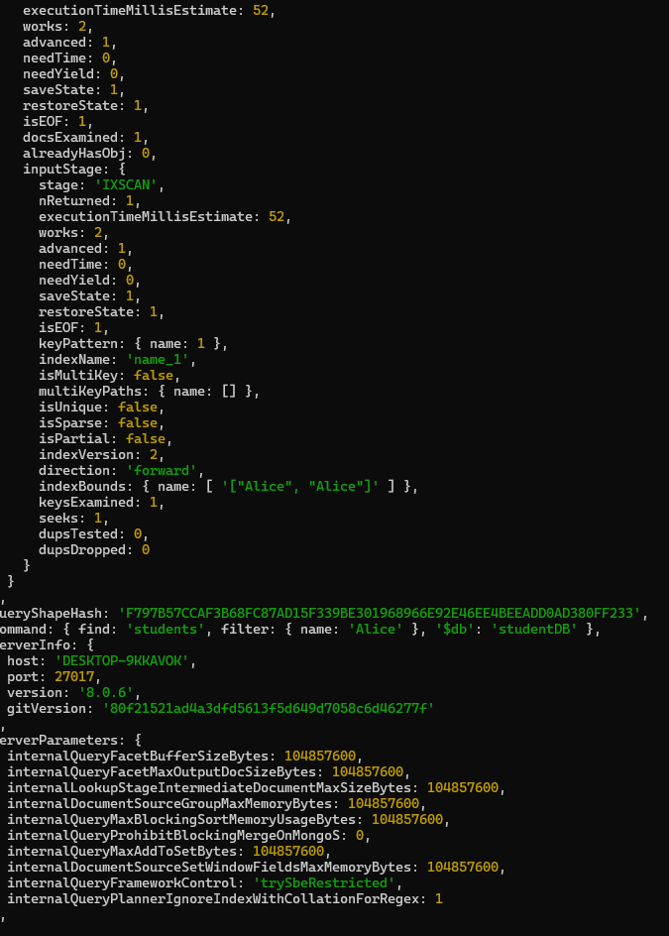**16. Aggregation and Data Analysis**

**• Perform aggregation using $match, $group, and $sort.**

**• Generate summarized data reports.**

**CODE & OUTPUT:-**

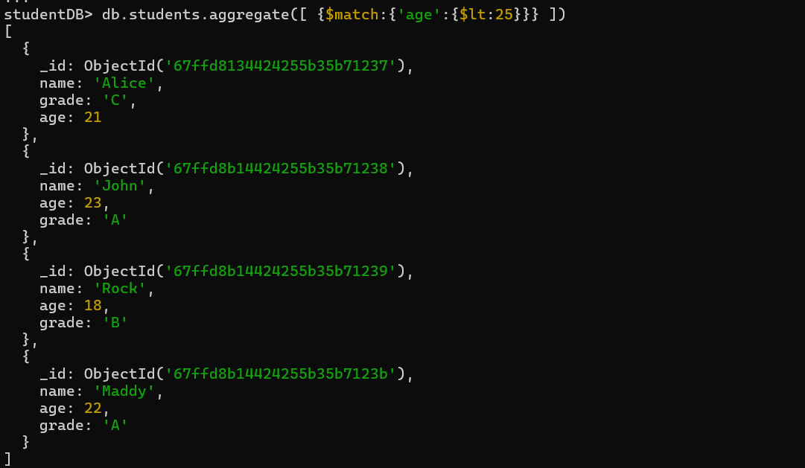

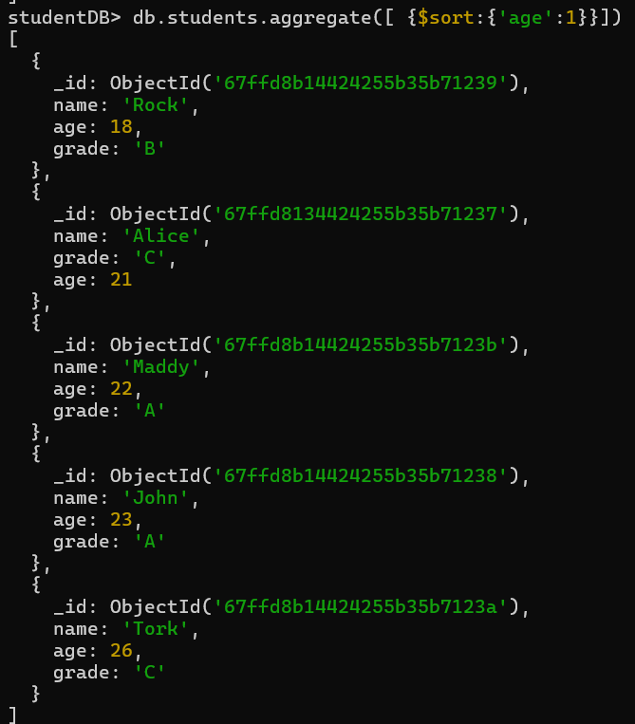

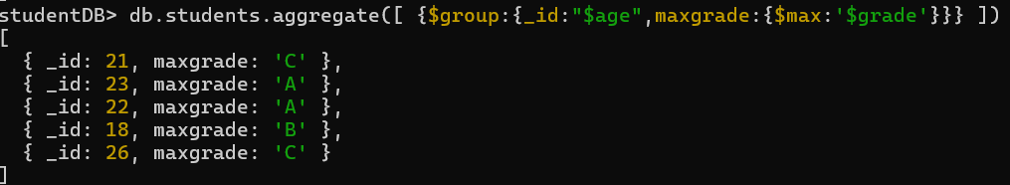

**17. Backup and Restore in MongoDB**

**• Perform data backup and restoration using mongodump and mongorestore.**

**• Practice exporting and importing large datasets**

**CODE & OUTPUT:-**

**BACKUP- mongodump --db=mydatabase --out=/backups/mongodump-2025-04-23**

**RESTORE-- mongorestore --db=mydatabase /backups/mongodump-2025-04-23/mydatabase**

**IMPORT AND EXPORT FILE-- mongoimport --db=mydatabase --collection=mycollection --type=csv --headerline --file=large-data.csv**